# Short Overview & Destination Audience

MyHealth Tracker is a wellness web application that offers personal health solutions to the population aged 18 to 45 who need sustainable health practices. Users are able to add food diaries of their meals, exercise, drinking water, and their mood with the help of a simple and user-friendly interface. The system collects the information and gives it insights in the form of visual representations such as graphs and trends over a period. The application will enable people to track their health, be accountable and make better lifestyle habits.

# Benefit to the User

* Promotes whole body health awareness
* Provides a commonplace to monitor and visualise routines
* It is available on any device through a responsive UI
* Aids in the discovery of the links between habits and mood

# Technical Concept / Software Stack

|  |  |  |
| --- | --- | --- |
| **Component** | **Technology** | **Rationale** |
| Frontend | React.js + CSS | Modern, dynamic, scalable, responsive |
| Backend | Node.js + Express | Flexible API handling, easy MongoDB integration |
| Database | MongoDB Atlas | Schema-free, good for flexible data logging |
| Hosting | Netlify (Frontend) + Render (Backend) | Free-tier suitable for academic deployment |
| Other Tools | Chart.js, GitHub | Data visualisation, version control |

# Architecture Overview

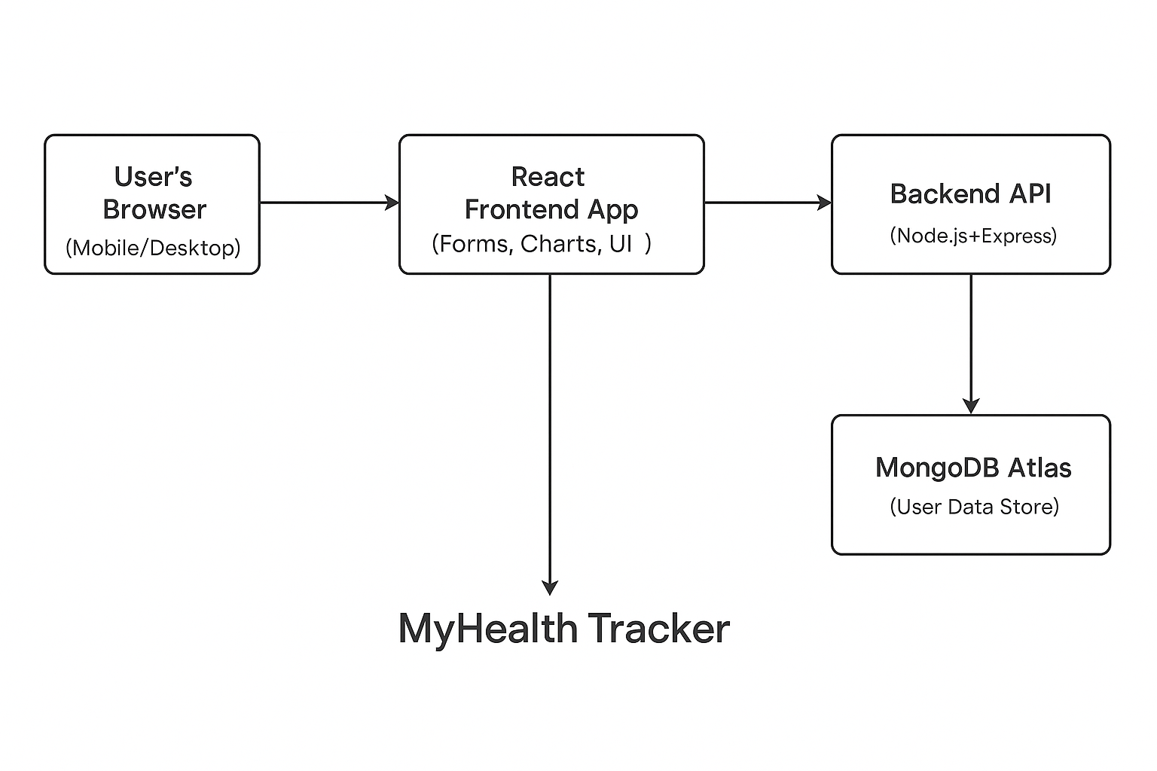

Figure 1: Architecture Overview in a digital graphic format (source: self-made)